**HTML**

**ASSIGNMENT:1**

**Q1.** Are the HTML tags and elements the same thing?

ANS. No, HTML tags and elements are not the same thing .

HTML tags are used to hold the HTML elements.

HTML elements is used to hold the content .

HTML tags usually exist in pairs consisting of a starting and an ending tag. However, some tags do not have a closing tag .

**Q2.** What are tags and attributes in HTML?

**Ans. HTML Attributes:**

HTML Attributes is used to define the character of an HTML element.

It always placed in the opening tag of an element.

It generally provides additional attribute to the element.

**HTML Tags:**

HTML Tags are the starting and ending parts of an HTML element. They begin with < symbol and end with > symbol. Whatever is written inside < and > are called tags.

**Q3.** What are void elements in HTML?

**Ans.** There is a special group of elements that only have start tags and does not contain any content within it, these elements are called void elements.

Void elements doesn’t have ending tags and can only have attributes but do not contain any kind of content.

These elements can have backslash before ending of start tag but that is completely optional.

Example of such elements are <br>, <hr>, <img>, <input>, <embed> etc.

Characteristics:

Void elements do not have end tags.

Void elements cannot have content inside it.

Void elements have attributes.

**Q4.** What are HTML Entities?

**Ans.** HTML provides some method to display reserved characters.

Reserved characters are those characters that are either reserved for HTML or those which are not present in the basic keyboard.

For instance, ‘<‘ is reserved in HTML language.

Sometimes this character needs to display on the web page which creates ambiguity in code.

Along with these are the characters which are normally not present in basic keyboard ( £, ¥, €, © ), etc.

HTML provides some Entity names and Entity numbers to use these symbols. Entity names are case-sensitive.

Entity number is easy to learn.

**Q5.** What are different types of lists in HTML?

**Ans.** There are 3 types of list in HTML : (1) Ordered List

(2)Unordered List

(3) Define

(1) Ordered List: (1) A

(2) a

(3) I

(4) i

(5) Default number

(2) Unordered List: (1) circle

(2) square

(3) disc

(3) Define

**Q6.** What is the ‘class’ attribute in HTML?

**Ans.** The class attribute specifies one or more classnames for an element.

The class attribute is mostly used to point to a class in a style sheet.

However, it can also be used by a JavaScript to make changes to HTML elements with a specified class.

**Q7.** What is the difference between the ‘id’ attribute and the

‘class’ attribute of HTML elements?

**Ans. HTML id Attribute:** The id attribute is a unique identifier that is used to specify the document.

It is used by CSS and JavaScript to perform a certain task for a unique element. In CSS, the id attribute is written using the # symbol followed by id.

**HTML class Attribute:** The class attribute is used to specify one or more class names for an HTML element.

The class attribute can be used on any HTML element.

The class name can be used by CSS and JavaScript to perform certain tasks for elements with the specified class name.

The class name in CSS stylesheet using “.” symbol.

**Q8.** What are the various formatting tags in HTML?

**Ans.** HTML provides many predefined elements that are used to change the formatting of text. The formatting can be used to set the text styles (like – bold, italic, or emphasized, etc.), highlight the text, make text superscript and subscript, etc.

Example: <b>, <strong>, <em>, <i> etc.

**Q9.** How is Cell Padding different from Cell Spacing?

**Ans. Cellpadding:** Cellpadding specifies the space between the border of a table cell and its contents (i.e) it defines the whitespace between the cell edge and the content of the cell.

**Cellspacing:** Cellspacing specifies the space between cells (i.e) it defines the whitespace between the edges of the adjacent cells.



**Q10.** How can we club two or more rows or columns into a single row or column in an HTML table?

**Ans.** The purpose of this article is to explore the method of merging table cells in HTML using the rowspan and colspan attributes.

By utilizing rowspan, multiple cells in a row can be merged or combined, while colspan enables the merging of cells in a column within an HTML table.

This technique proves essential for creating visually organized and structured tables, and optimizing the presentation of data.

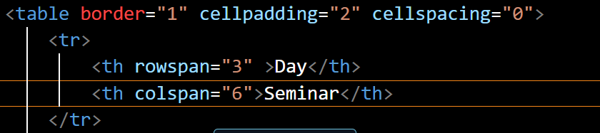

**Q11.** What is the difference between a block-level element and an inline element?

**Ans.** A block-level element always starts on a new line, and the browsers automatically add some space (a margin) before and after the element.

A block-level element always takes up the full width available stretches out to the left and right as far as it can.

Two commonly used block elements is <p>.

The <p> element defines a paragraph in an HTML document.

Example:<ol> , <p>, <hr>, <table>, <pre> etc.

**Q12.** How to create a Hyperlink in HTML?

**Ans.** To insert a hyperlink in a HTML page, we have to utilize the anchor tags <a> and </a> labels, which are used to characterize the connections.

The <a> tag demonstrates where the hyperlink begins and the < / a> tag shows where it closes.

Whatever text gets added inside these labels, will function as a hyperlink.

Add the URL for the connection in the <a href = " ">

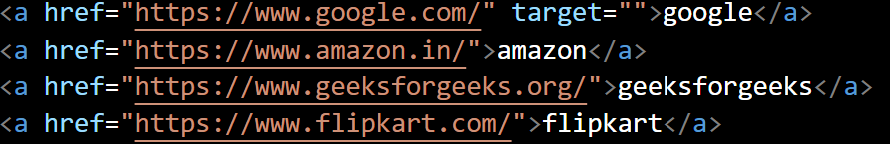

**Q13.** What is the use of an iframe tag?

**Ans.** The iframe tag in HTML stands for Inline Frame and is used to embed another HTML document within the current document.

It supports various attributes for specifying dimensions, borders, scrolling, and more to customize the appearance and behavior of the embedded content.

It requires an src attribute specifying the URL of the document to be embedded.

Also enables the inclusion of videos, maps, or entire web pages from other sources.

**Q14.** What is the use of a span tag? Explain with example?

**Ans.** The HTML <span> tag is a generic inline container for inline elements and content.

It is used to group elements for styling purposes by using the class or id attributes.

A better way to use it when no other semantic element is available.

The span tag is a paired tag means it has both open(<) and closing (>) tags, and it is mandatory to close the tag.

The span tag is used for the grouping of inline elements & this tag does not make any visual change by itself.

**Q15.** How to insert a picture into a background image of a web page?

**Ans.** Beautiful webpages are a very strong means of catching user attention.

In this article, we are going to see how we can add an image as the background image of a web.

There are two approaches to setting an image as the webpage's background image, which we will learn in this article.

**Q16.** How are active links different from normal links?

**Ans.** Websites are designed to point you to different resources.

You can move from one website to another through links.

Links help you to get information from different resources.

Links are established in simple HTML web pages through <a> tag.

Links are categorized into three types.

Typically a Link is displayed in three different colors based on the usage.

Normal links (Unvisited links), Visited links ,Active links.

**Q17.** What are the different tags to separate sections of text?

**Ans.** HTML Section tag defines the section of documents such as chapters, headers, footers, or any other sections.

The section tag divides the content into sections and subsections.

The section tag is used when requirements of two headers or footers or any other section of documents are needed.

Section tag grouped the generic block of related contents.

The main advantage of the section tag is, it is a semantic element, which describes its meaning to both browser and developer.

In this article, we will discuss how to separate a section from another section in HTML.

**Q18.** What is SVG?

**Ans.** SVG is a text-based, open Web standard for describing images that can be rendered cleanly at any size and are designed specifically to work well with other web standards including CSS, DOM, JavaScript, and SMIL.

SVG is, essentially, to graphics what HTML is to text.

SVG images and their related behaviors are defined in XML text files, which means they can be searched, indexed, scripted, and compressed.

Additionally, this means they can be created and edited with any text editor or with drawing software.

**Q19.** What is difference between HTML and XHTML?

**Ans.** **XHTML:** XHTML stands for Extensible Hypertext Markup Language.

It can be considered as a part of the XML markup language this is because XHTML has features of both XML and HTML.

XHTML is extended from XML and HTML.

XHTML can be considered as a better version of HTML.

**HTML :** HTML is the Hypertext Markup Language which is the most widely used language over the internet.

HTML is used to create web pages and link them from one to another.

HTML is not a programming language, it is a markup language.

We can use different other technologies as like CSS and javascript to give a new look to the pages developed by HTML.

**Q20.** What are logical and physical tags in HTML?

**Ans. Physical Tags :** Physical Tags are used in HTML to provide actual physical formatting to the text. The Physical tags commonly used in HTML.

Example: <b> , <i> , <sup> , <sub> , <u> etc.

**Logical Tags :** Logical Tags are used in HTML to display the text according to the logical styles. The Logical tags commonly used in HTML.

Example: <abbr> , <address> , <del> , <ins> etc.